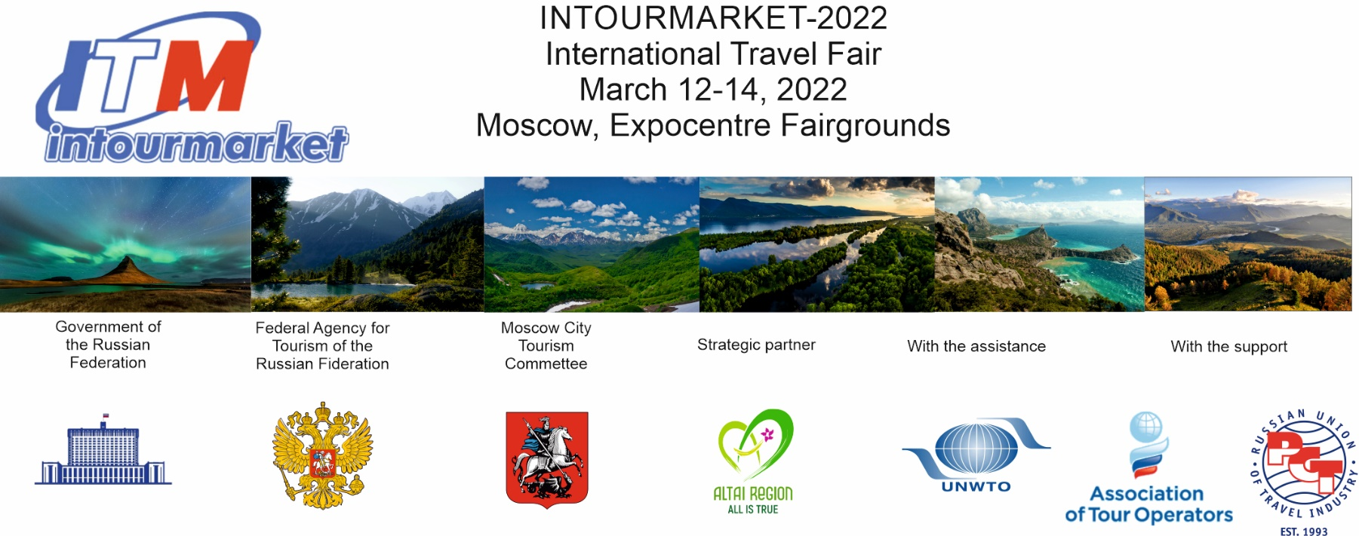

Press release of the XVII Intourmarket International Travel Fair

In 2022, the Intourmarket International Travel Fair will be held on March 12-14 at the Expocentre Fairgrounds.

Official support of the exhibition:
• Government of the Russian Federation
• Federal Agency for Tourism
• Russian Union of Tourism Industry (RST)
• Association of Tour Operators of Russia (ATOR)

Event Partners:
· Partner regions of the exhibition: Republic of Khakassia, Leningrad Region, Krasnoyarsk Krai
· Partner city: Saint Petersburg
· Official partner: Republic of Bashkortostan
· Interregional partner of the exhibition: the Silver Necklace project
· General B2B Media Partner: Profi.Travel
· General Media Partner: Vesti.Tourism
· General Internet Partner: Tourprom
· General News Partner: Travel Russian News (TRN)

The Intourmarket International Travel Fair is a field-oriented tourist platform for expanding intra-industry dialogue and developing best solutions and ways to advance the market in new conditions. The exhibition is traditionally a most important event of the Russian tourism.

It is at the Intourmarket that effective mechanisms are developed and inter-industry ties are established, which help to form new quality tourist products and elevate service in the industry to higher standards. The event highlights the most active representatives of the country’s travel industry and acts as a uniting networking platform. It makes happy, surprises, sets up for work, unites the best!

Professionals expand their business opportunities at the exhibition, travelers find answers to the questions: “How to travel?”, “Where to go?”, “Where to stay?”, “What to visit?”, “What to take with us?” and others. All Intourmarket guests are happy to note the amazing festivity atmosphere created at the exhibition.

The Intourmarket is the only exhibition in Russia that demonstrates the full range of national tourist product — more than 70 regions of Russia participate in the event. Intourmarket is “at the peak” of the focal tourist trend — import substitution in tourism. At the same time, foreign countries also participate at the exhibition.

The Intourmarket International Travel Fair is a place of discoveries and prospects. The Intourmarket is a fête for tourists and travel professionals.

The exhibition business program will be action-packed: more than 60 business sessions with the participation of over 200 speakers are to be held at five venues in the Expocentre complex. Industry professionals will not only discuss demanding issues in a close dialogue, but also find solutions to many pressing topics.

Key business events of the Intourmarket-2022

· Subject-oriented business session: IT-technologies in the Silver Necklace of Russia interregional tourist project
· Business Forum: Tourism, creative codes, creative industries — the best municipal practices in Russia
· Workshop: The consequences of the special operation. The life of a travel agent in a new reality
· Contest of regional RST participants presentations: 10 minutes of glory
· Working session of the regions participating in the Imperial Route national tourist project
· Plenary session on topical issues of industry development
· Training workshop for the regions organized by the ALEAN National tour operator: Discover Russia with ALEAN. A new insight in well-known regions: how to become a sales expert for a regional product
· Creating More than a Tour: experience of implementing the federal program (2021-2024). Development of new approaches to the creation of cultural and educational tours
· Presentation of the tourist potential of Primorsky Krai in the presentation format with elements of augmented reality
· Conference: PravTurSoyuz Open Dialogue: New Trends and Challenges of 2022
· Practical session: Safety of children’s tourism: pain points and solutions
· Expert session of the Management company of Sverdlovsk region tourist and recreational clusters
· Round table on the interregional socio-cultural project: Birch bark letters to the future. XXI century. The Russian great story of great Russian writers
· Expert round table: It is necessary to get culturalized: educational tourism and cultural development of cities
· Dialogue platform: Implementation of sustainable development mechanisms in tourism and hospitality industry
· Master session: Formation of demand for sustainable tourism products. How to promote to be noticed?
· Meet-up session: Key trends in modern approaches to the development of tourism in natural areas
· Media Forum: #ПораПутешествоватьПоРоссии at the Intourmarket International Travel Fair
· Round table: Modern excursion activities: regulatory framework, educational programs, regional practice and prospects of branded routes
· Workshop: Tourism and the Law. New legislation in tourism, challenges and opportunities
· Panel discussion: Development of Arctic tourism in single-industry towns on the example of Monchegorsk (Murmansk region)
· All-Russian MICE Day
· Panel discussion: The Far East and the Arctic: new opportunities for travel. Summer 2022
· Presentation: Krasnoyarsk Krai. A must-to see for everyone!
· Presentation: Tourist products of the Baikal region
· Round table: Wellness tourism: birth, sustainability or growth? Current trends and products of Russian wellness hospitality
· Interregional charity auction: Tourist business with an open heart in favor of the wards of the Children’s Lighthouse Hospice
· The final of the All-Russian MediaTour competition
· III All-Russian Conference: How to attract celebrities to branding territories
· Presentation: Discover the Free Don! All about hospitality and tourist products of the Rostov region
· Conference: From the Black Sea to the White Sea. Autotourism as a unique tool for the development of territories
· Training workshop for tourist information centers
· Workshop of participants and partners of the Exciting weekend in the Volga region interregional project
· VII All-Russian Russia Eventful forum as part of the Time to Travel in Russia educational forum
· Joint event of the Moscow Tourism Committee and the St. Petersburg Tourism Development Committee: Two cities — a million impressions
· Practical session on Internet promotion for tourist information centers, museums, regional tour operators and other market participants
· Presentation of the tourist potential of the Kaliningrad region — the country ‘s westernmost region
· Session: Developing ethnotourism — preserving the cultural code of the peoples of Russia
· Working meeting on the issues related to bus sightseeing transportation of the RST Bus Transportation Commission
· Round table: Rural and wine tourism in Russia — new impressions, new opportunities for development of tourism business and regions
· Presentation of the Chuvash Republic tourism potential for the Moscow travel industry
· Working meeting of the RST Commission on River Cruises: Navigation 2022. Future development of cruise tourism in the new economic conditions
· Session of the International Round Table: CIS+world. The World of Professionals 2022
· Conference: Intelligent Travel Marketing
· Case session: Educational tourism. Best practices and collaboration formats
· Workshop: Autotourists and tourist routes are the new blood for the revival of villages and historical settlements

The complete program of the Intourmarket events is on the exhibition website www.itmexpo.ru

March 13, the second day of the Intourmarket International Travel Fair, according to tradition, has been declared the Charity Day

Our goal is to support the Children’s Lighthouse Hospice, which takes care of children with incurable diseases and functions on private donations. The focal event of the campaign is a Charity auction, all funds from which will go to the Children’s Lighthouse Hospice for the purchase of special equipment for children who have restricted mobility for health reasons. Any kind of your participation in this heartful project is welcome! Exhibition organizer: Expotur LLC (Russia)

For more detailed information about the exhibition visit the website www.itmexpo.ru

* phones: +7 (495) 762-87-65, +7 (495) 626-43-69, +7 (495) 626-21-73
• e-mail: itm@itmexpo.ru
• Venue: Expocentre Fairgrounds, Forum Pavilion, Vystavochnaya metro station

See you at the Intourmarket travel expo on March 12-14 at Expocentre!

